ZBRAJANJE I ODUZIMANJE (38+7), (32-5), (30+26), (47-30), (33+23), (45-31)

62 + 9 = ___ 48 + 3 = ___ 41 – 2 = ___
85 + 7 = ___ 5 + 38 = ___ 36 – 8 = ___
2 + 79 = ___ 29 + 5 = ___ 25 – 9 = ___
78 + 4 = ___ 19 + 5 = ___ 83 – 8 = ___
6 + 46 = ___ 82 - 9 = ___ 24 – 7 = ___
77 + 5 = ___ 45 – 6 = ___ 87 – 9 = ___
4 + 58 = ___ 27 – 8 = ___ 34 – 8 = ___
35 + 6 = ___ 38 – 9 = ___ 82 – 8 = ___

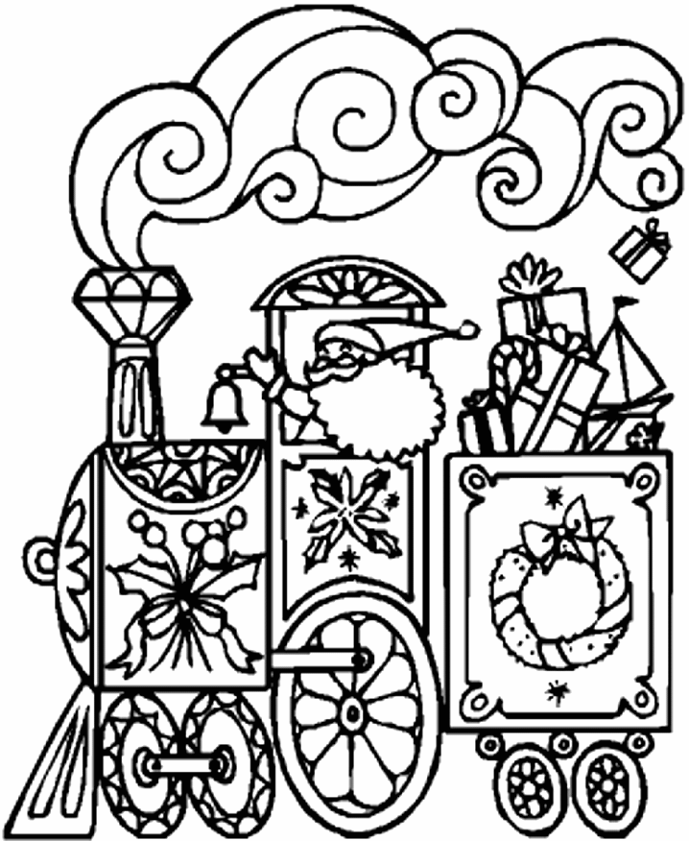
87 + 10 = ___ 53 +30 = ___ 67 – 50 = ___
25 + 30 = ___ 30 + 24 = ___ 59 – 20 = ___
40 + 53 = ___ 77 + 20 = ___ 31 – 10 = ___
56 + 20 = ___ 40 + 18 = ___ 88 – 60 = ___
62 + 30 = ___ 45 – 30 = ___ 47 – 40 = ___
85 + 10 = ___ 51 – 30 = ___ 61 – 40 = ___
20 + 71 = ___ 53 – 50 = ___ 51 – 20 = ___
73 + 10 = ___ 21 – 10 = ___ 83 – 60 = ___

65 + 24 = ___ 84 + 15 = ___ 25 – 13 = ___
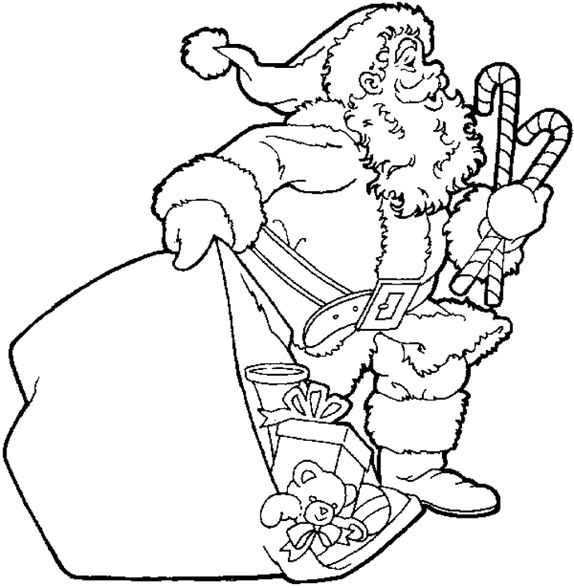
73 + 13 = ___ 53 + 42 = ___ 92 – 71 = ___
47 + 51 = ___ 27 + 32 = ___ 34 – 22 = ___
32 + 53 = ___ 46 + 31 = ___ 89 – 48 = ___
41 + 11 = ___ 54 – 32 = ___ 67 – 25 = ___
25 + 42 = ___ 39 – 28 = ___ 59 – 24 = ___
42 + 12 = ___ 78 – 72 = ___ 33 – 11 = ___
54 + 34 = ___ 99 – 63 = ___ 89 – 82 = ___

